**Data Structure and Algorithms Lab**

**Code: PMDS605P**

**Digital Assignment 2**

**Name: Soumyadeep Ganguly**

**Reg. No.: 24MDT0082**

**Course: M.Sc. in Data Science**

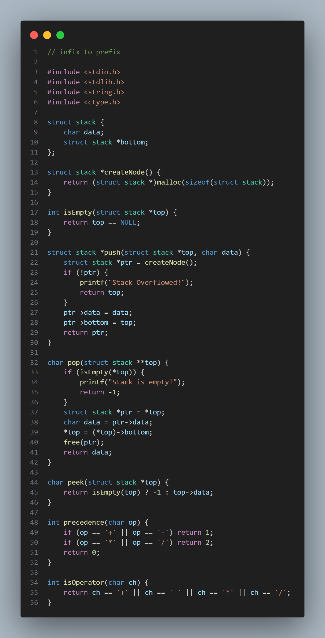**Convert infix to prefix**

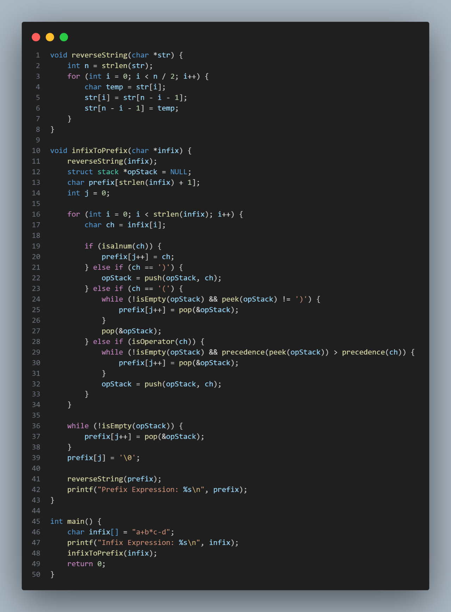

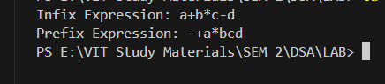**OUTPUT:**